Minimum Sailing Rules SR Bell Feb 2022
Right of way rules
A port tack boat keeps clear of a starboard tack boat.
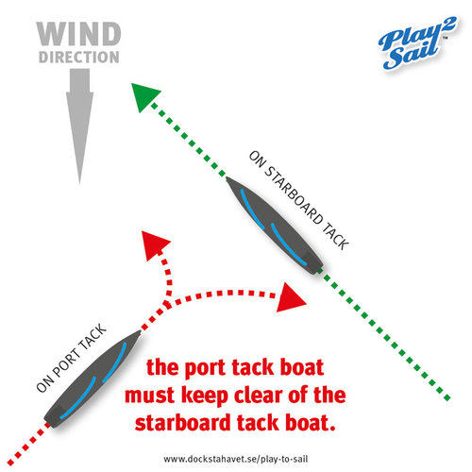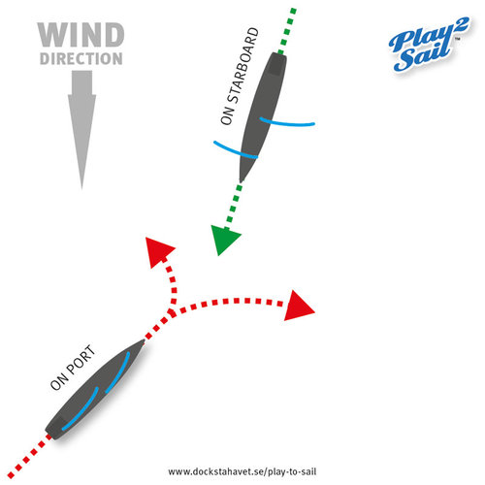
When boats are overlapped on the same tack the windward one must keep clear of the other one
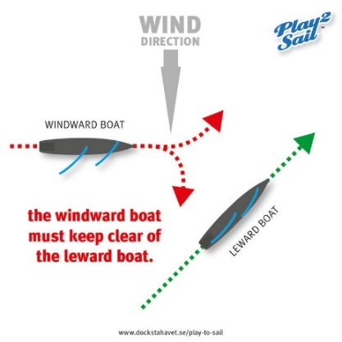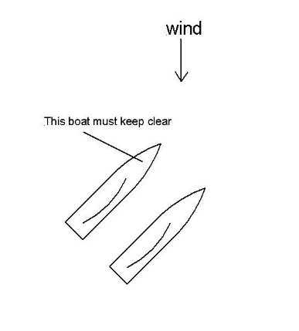
A boat that is coming from behind must keep clear of the one ahead ie not sail into the back of it.
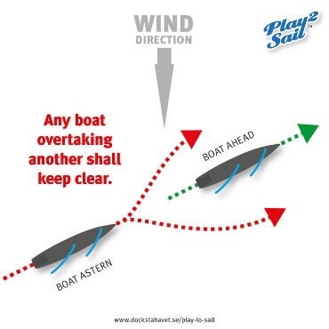
Limitation rules
During tacking a boat has no rights so don’t tack if you will hinder another boat, you may have to wait till the other boat has tacked.
A right of way boat changing course must give room to a boat trying to keep clear. ie if you are on starboard tack you mustn’t turn into a port boat that was avoiding you.

Mark rounding
You must avoid hitting a mark that is part of the course, you have to do a penalty turn if you hit one.
At the upwind mark the port and starboard rule still applies, if approaching on port you may have to sail round the back of the boats that are coming in on starboard tack.
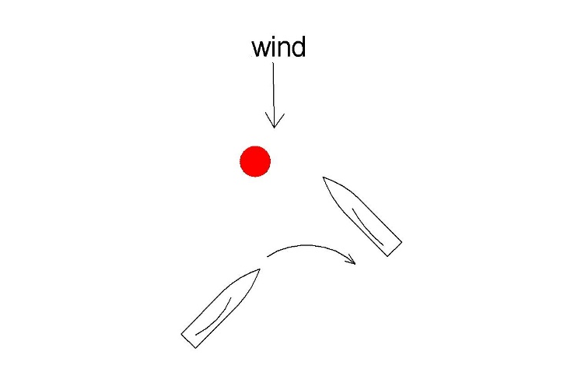

Giving room
- At the upwind mark if boats are overlapped on the same tack then the boat outside must give the inside one room to get round the mark. Note this does not include giving room to tack. Ie the inside boat must be able to sail up to the mark without needing to tack.

- At other marks when overlapped boats are within 4 boat lengths then the outside boats must give the inside boats room to get round the mark, NOTE they can be on port or starboard tack from the 4 boat length zone. You can call out “room for the mark” if you think there is going to be a squeeze.

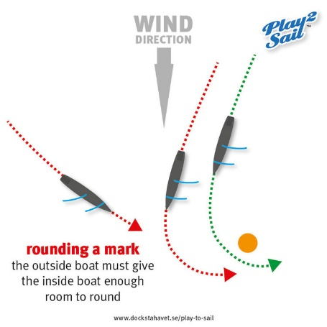
Penalty turns
If you break any of the rules then you must do at least one penalty turn, to do one of these you must first sail clear of other boats nearby then turn your boat 360deg ie one tack and one gybe. If you have broken a rule and after doing a turn you are still ahead of the boat you disadvantaged then you must do further turns till that boat has got past yours!
Obstructions if your yacht is heading to a bank or a group of right of way boats, and there are other boats around, you must ask for room to tack, this gives the other boats a warning that you will need to tack to avoid the obstacle. Call out your boat number and “room to tack”
acknowledgement of use of diagrams from the Play2 Sail radio sailing academy website.

